Functional Grammar

🔹 What is Functional Grammar
# Source: Chatgpt (GPT-4-turbo) at [8/3/2025]
Functional grammar is a type of grammar that explains how language is used to achieve communication goals.
Rather than focusing on sentence structure alone, it emphasizes the function of language in real-life contexts—what words and structures do, not just what they are.
This approach is strongly associated with Michael Halliday, who developed Systemic Functional Grammar (SFG).

✅ Key Features of Functional Grammar:
# Source: Chatgpt (GPT-4-turbo) at [8/3/2025]
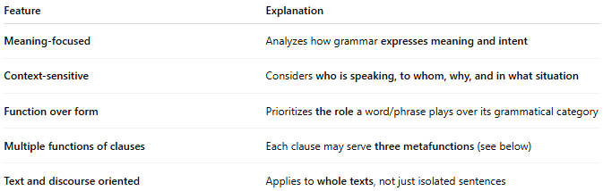
Feature | Explanation
Meaning-focused | Analyzes how grammar expresses meaning and intent
Context-sensitive | Considers who is speaking, to whom, why, and in what situation
Function over form | Prioritizes the role a word/phrase plays over its grammatical category
Multiple functions of clauses | Each clause may serve three metafunctions (see below)
Text and discourse oriented | Applies to whole texts, not just isolated sentences

✅ The Three Metafunctions (Halliday’s Model):
# Source: Chatgpt (GPT-4-turbo) at [8/3/2025]
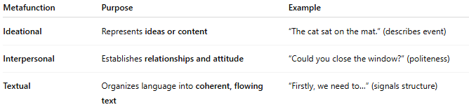
Metafunction | Purpose | Example
Ideational | Represents ideas or content | “The cat sat on the mat.” (describes event)
Interpersonal | Establishes relationships and attitude | “Could you close the window?” (politeness)
Textual | Organizes language into coherent, flowing text | “Firstly, we need to…” (signals structure)

✅ Examples of Functional Perspective:
# Source: Chatgpt (GPT-4-turbo) at [8/3/2025]
Sentence: "She must be tired."
- Ideational function: Expresses a judgment about her state
- Interpersonal function: Uses “must” to show speaker’s inference
- Textual function: May connect to earlier context (“She worked all day. She must be tired.”)

✅ Structural vs. Functional View:
# Source: Chatgpt (GPT-4-turbo) at [8/3/2025]
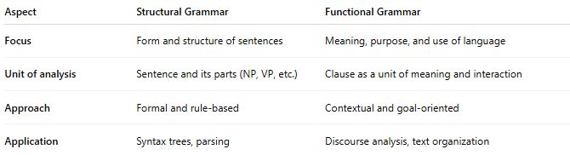
Aspect | Structural Grammar | Functional Grammar
Focus | Form and structure of sentences | Meaning, purpose, and use of language
Unit of analysis | Sentence and its parts (NP, VP, etc.) | Clause as a unit of meaning and interaction
Approach | Formal and rule-based | Contextual and goal-oriented
Application | Syntax trees, parsing | Discourse analysis, text organization

✅ Why Functional Grammar Matters:
# Source: Chatgpt (GPT-4-turbo) at [8/3/2025]
- Explains how grammar choices affect meaning
- Helps understand language variation across contexts
- Useful for teaching academic writing, analyzing literature, and studying discourse
- Bridges grammar and pragmatics (language in use)

✅ Comparison with Other Grammar Types:
# Source: Chatgpt (GPT-4-turbo) at [8/3/2025]
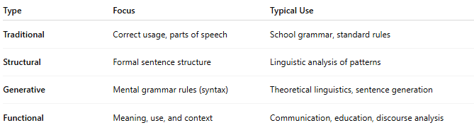
Type | Focus | Typical Use
Traditional | Correct usage, parts of speech | School grammar, standard rules
Structural | Formal sentence structure | Linguistic analysis of patterns
Generative | Mental grammar rules (syntax) | Theoretical linguistics, sentence generation
Functional | Meaning, use, and context | Communication, education, discourse analysis

📝 Summary:
# Source: Chatgpt (GPT-4-turbo) at [8/3/2025]
- Functional grammar explores how grammar serves communication.
- Developed by Michael Halliday, especially through Systemic Functional Grammar.
- Emphasizes meaning, social context, and interaction.
- Analyzes whole texts rather than just isolated sentences.

